

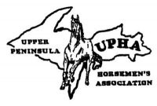

**The official rule book of the**

**Upper Peninsula Horsemen’s Association**

**Since 1965……**

**Revised 2023**

**OUR OFFICIAL WEBSITE**

UPHA.NET

**2023 Directors**

|  |  |
| --- | --- |
| President Karen Hendrickson 405 Yelle Rd Gwinn MI 49841 (906) 346-6139  [performanceplusstables@hotmail.com](mailto:performanceplusstables@hotmail.com) | Vice President  Janece Hanycz  108 Hillcrest Trail  Marquette MI 49855  (906) 458-0118 |
| Secretary Abby Woodaz-Rahn  Munising MI 49862  (906) 202-2121  uphasecretary@gmail.com | Treasurer  Lisa Pellegrini  PO Box 104  Gwinn MI 49841  (906) 250-7234  rodemo@charter.net |

|  |  |
| --- | --- |
| Point Secretary Judith Nelson 10652 Hwy M35  Gladstone MI 49837 (906) 428-3788 | Assistant Point Secretary  Sue Asplund  N10694 O.1 Lane  Daggett Mi 49821  (906)458-7995 |

Director Alternates

Robynne Woodaz Phyllis LaCombe

Dianne LaChance

**UPPER PENINSULA HORSEMEN’S ASSOCIATION**

SHOW RULES 2023

FORWARD

The U.P.H.A. (Upper Peninsula Horsemen’s Association) originated at annual meetings held by various 4-H Club leaders and other interested horsemen over a period of years. The need for such an organization was evident and finally, at the annual fall meeting of 4-H leaders which was held at Harvey, Michigan during the winter of 1964, a plan was offered and a meeting place suggested for the formation of such an organization.

On January 10, 1965, sixty-five (65) interested horsemen from the central and western portions of the Upper Peninsula of Michigan met at the Mansfield Township Hall near Crystal Falls and after discussing the merits of such an organization, officers were elected and a meeting date and place set for the first director’s meeting.

The U.P.H.A. was organized primarily to provide more recreation for Horsemen, to promote better horses and horsemen, to offer association stock sales, and increase interest in shows and gymkhanas.

This rule book is intended to assist clubs and individuals in planning, sponsoring, and staging a show and to provide a guide for showing horses under a standard pattern or uniform set of rules.

Some of the terminology contained in this rule book was taken from various established rule books and the remainder was prepared by the committee of rules.

The officers and directors of the U.P.H.A. take this opportunity to express their sincere appreciation to those who helped make this association possible.

**CONSTITUTION OF THE UPPER PENINSULA HORSEMEN’S ASSOCIATION**

**ARTICLE I. Name:**

The name of this corporation shall be the Upper Peninsula Horsemen’s Association, U.P.H.A.

**ARTICLE II. Objectives:**

A. This corporation is organized as a non-profit, non-stock organization pursuant to Michigan statutes.

B. To help promote horse shows, trail rides, stock sales, gymkhanas, etc. in Upper Michigan.

C. To provide a system whereby members may compete for championships in various events.

D. To gain publicity through use of newspapers, radio and television, to benefit horse shows, stock sales, etc.

**ARTICLE III. Membership:**

A. Persons paying annual dues and abiding by the regulations of the U.P.H.A. shall be considered members.

B. Membership is available to persons living in the neighboring states.

C. Membership is open at all times and opportunity to join the U.P.H.A. will be offered at all shows, sales or any other U.P.H.A. sanctioned activity.

D. One rule book will be given with each membership.

**ARTICLE IV: Location of Business Office.**

The Address of the business shall be that of the Secretary.

**ARTICLE V. Officers:**

**A.** Seven Directors and Five Alternates will be nominated 30 days prior to voting. Officers will not represent a particular county. New officers will be considered Directors thereafter for legal purposes. These Officers and Alternates will serve for a term of one year. Officers and Alternates must pay their membership by the first meeting of the year. The officers shall be Chairperson, Vice Chairperson, Secretary, Treasurer, Point Secretary and Assistant Point Secretary. No Alternate will have nominating or voting powers unless they are representing an absent director at a regular monthly meeting.

B. The Chairperson shall preside at all meetings of the association and of the Board of Directors, shall be responsible to appoint committees and call any special meeting. The Chairperson will be responsible for the ordering of all awards.

C. The Vice-Chairperson shall act as Chairperson in the absence of the Chairperson. The Vice-Chairperson should assist the Chairperson with all duties and responsibilities requiring assistance.

D. The Secretary shall keep minutes of all meetings, shall arrange for members to be informed of notices of same when necessary, and store all association documents and paperwork. The Secretary is responsible for all U.P.H.A. correspondence.

E. The Treasurer shall pay all bills of the U.P.H.A. when approved by the Chairperson, Vice-Chairperson or the Board, and provide monthly and end of year financial reports. A special meeting will be held called an auditing meeting. The committee will be appointed by the President. Meeting needs to be held prior to the November meeting to audit the Fiscal year November 30 thru November 29.

F. The Point Secretary will keep track of all points accumulated by any paid member. The Point Secretary shall be responsible for purging all show results sheets, every year, keeping records for twenty years then destroy. The Point Secretary will be responsible for obtaining and recording of all U.P.H.A. memberships, and provide a list of all members eligible to vote. The Point Secretary will also be responsible for maintaining the U.P.H.A. laptop and the show program to track all the current points.

G. The Assistant Point Secretary will work with the Point Secretary throughout the year and compare at the end of the year for accuracy.

**ARTICLE VI. Directors:**

A. Directors shall be members in good standing of the U.P.H.A. and be residents of the U.P.

B. Directors shall not expect any compensation for expenses at or travel to and from meetings.

C. Vacancies on the Board of Directors may be filled by action of the Board until the next annual meeting. If a member of the Board of Directors misses more than three meetings in one year without good cause, he or she may be suspended and replaced by the Board of Directors.

D. A quorum shall be 3/4 of the paid directors present.

E. All directors will register at shows they attend with the show committee.

F. Directors annual dues must be paid on or before the January meeting following the annual meeting.

**ARTICLE VII. Amendments:**

A. Proposed amendments shall be submitted to the U.P.H.A. Secretary at least thirty (30) days in advance of the General Members meeting so they may appear at the meeting. The proposed amendments shall be presented to the officers at the next Board meeting.

B. Amendments to rules and regulations will be decided by a majority vote of ¾ of the paid members present. Voting privileges are for paid U.P.H.A. members 18 years and over.

**ARTICLE VIII. Meetings:**

A. The annual awards banquet and gathering will be at end of season.

B. The General Membership meeting will be held on a date after the Awards Banquet. The purpose of this meeting is to elect six officers and six alternates from the ballots submitted by the Secretary. This meeting will also make any other necessary changes such as class or rule changes, membership dues, etc.

C. Notice of any meeting shall be given to members, committees or directors at least three days and not more than thirty days in advance. Special meetings may be called by the Chairperson, majority of Board of Directors or any ten members.

D. There will be no taping of U.P.H.A. meetings without approval of the Directors.

**UPPER PENINSULA HORSEMEN’S ASSOCIATION SHOW RULES**

**SECTION I. General Rules:**

A. All shows require exhibitors to present a current negative Coggins Test for each horse brought on the grounds to show.

B. All contestants wishing to accumulate points must be a paid U.P.H.A. member. Contestants, who are not paid members, cannot accumulate points for year-end awards or special awards. Point accumulation will be effective at the time the contestant is a paid member however, points are not retroactive. Membership and sanction fees will be determined annually by the Board. All exhibitors and contestants will be permitted the opportunity to join U.P.H.A prior to the start of any approved show by the Assistant Point Secretary or aides.

C. Any new clubs, organizations and individuals must apply to the U.P.H.A. for application to hold, sponsor or stage a show under U.P.H.A. rules and must submit to the U.P.H.A. by the March Directors meeting, a program of events. In the event any club feels a need to revise their program, it will have until the May meeting to resubmit their program. In the event any club fails to perform their program as submitted and approved by the U.P.H.A., it will lose all of its points for that show. Judges cards/ results have to attached to show results. It is further emphasized that the points lost would be for the entire show and not just for the event in which they occurred. It shall be the responsibility of the show committee to notify U.P.H.A. Directors of the show site and when inspection is convenient. Specifications and the diagram for an arena will be supplied by the U.P.H.A. The arena shall be an enclosed Area.

D. All shows will start at 8:30 AM in respected time zone.

E. Local sponsors may charge a maximum entry fee of $ 5.00 per class and a $ 1.00 office fee per contestant, per show.

F. All judging will be in accordance with U.P.H.A. rules and judges be on a current approved “Judges List” or have a current “Judges Card” from an approved equine association, and be approved by a majority of directors. No judge shall reside within the Upper Peninsula. A judge may judge no more than two years in a row. The show committee will post a form furnished by U.P.H.A., whereby any U.P.H.A. Member may write their approval/disapproval comments about the judge for that day and sign their name. The judge does not have to stay for speed events with the understanding that one U.P.H.A. Director or alternate be present and observing to settle disputes. An apprentice judge will be allowed in the ring, but the apprentice may not discuss the placing in the class with the judge, until the class has been placed and the judge’s card turned in.

G. The ringmaster or steward shall not take part in judging or discuss judging procedures with the judge. The ringmaster must remain neutral at all times. The ringmaster is in charge of all activities in the show arena. He/she is to assist the gate-person in admitting animals to and from the ring. He/she is to see that all animals registered in the class are present. He/she is to observe and enforce safety precautions and assist the judge only in situations where decisions of judging are not involved. The judge or ringmaster may call out any contestant at any time for improper attire, or horse and tack, for safety reasons.

Any complaint shall be presented to the ringmaster who shall with the steward or judge, discuss said complaint and make a decision before the next class is begun. All protests, not agreed on by all parties by the previous item, must be filed with the U.P.H.A. Secretary, or Board member if he/she is not available, within 48 hours of the show in which it occurred. A protest or charge must state the full name and address of the accused and contain a complete and definite statement of the act which constitute the alleged violation. Precise details regarding a violation of the rules is necessary. The maker of the protest must be prepared to substantiate the protest by personal testimony at a hearing or by sworn statements, witnesses or other evidence. The maker of the protest must be a contestant or guardian. A protest shall be accompanied by a $5.00 fee, to be refunded in the event the protest is validated.

H. No two sanctioned shows shall be held on the same day.

I. Exhibitors may show more than one horse in the same event if separate entries are submitted for each animal, except for Showmanship, Lead- Line, Lead-Line Trail, Pleasure, Equitation, and Horsemanship. Any member may show a horse for another member as long as in the same age division, except for Showmanship, English Equitation and Horsemanship which are judged on the exhibitor. Points will be awarded to the horse except for the same stated classes.

More than one person may ride the same horse, excluding open classes or in the same age group. Owner must decide at the beginning of the show season which classes qualify for 100 or 200 point awards. Year-end awards may be earned in all classes.

J. Five places will be awarded in each class. It is up to the show committee to award what they wish. Points will be determined by 1st place-5 points, 2nd place-4 points, etc. The accumulated points will be tallied towards awards at the U.P.H.A. End-of-Year Banquet.

K. There will be three year-end award winners in each class. The awards must be engraved as follows: U.P.H.A., Year, Grand Champion, Class; U.P.H.A., Year, Reserve Champion, Class; and a certificate for 3rd Place: U.P.H.A., Year, Third Place, Class.

In case of a tie, the horse with the most firsts will receive the higher award. In order to receive a year-end award, the horse and exhibitor must be a paid member.

If there is a high point year end award, you must participate in a minimum of 51% of sanctioned shows. If there is a single judged show that must be counted in the 50%.

L. Any horse or exhibitor accumulating 100 points or 200 points in any one division will receive a recognition award at the year-end banquet. These points may be earned under different riders and in different age groups. A horse or exhibitor may receive only one 100 point or 200 point award in each class.

M. Supreme Horse/Handler Awards

**Superior Horse Award**

**500 Points**

300 points - performance - points earned in a maximum of 4 classes - with a minimum of 100 points in English and Western.

50 points (minimum) - Halter - weanlings through aged classes

*color classes will not count

100 points (minimum) - Western Pleasure-Jr. & Sr. Horse – combo

Western Pleasure-Jv Jr. & Sr. Rider – combo

English Pleasure, Jr. & Sr. Horse-Combo

English Pleasure-Jv, Jr & Sr. Rider-Combo

.

50 points (minimum) - Barrels, Poles, or Plug - any combo

100 points (minimum) - Trail, Western Riding, Reining, Driving, Ranch Horse - any combo

Owner does not have to show horse for points to count.

Points stay with horse through new ownership.

**Superior Mini Award**

**250 Points**

75 points - Halter *color classes will not count

75 points - Mini trail

75 points - Driving

75 points – Extra in any event

Owner does not have to show horse for points to count.

Points stay with horse through new ownership.

**Supreme Handler Award**

**250 Points**

50 points (minimum) - Showmanship

50 points (minimum) – Horsemanship

50 points (minimum) - English Equitation

All other points can be earned in one or more classes.

Handler does not have to own horse for points to count.

Other rules that apply:

The award will be an appropriate award that will be presented at the awards banquet.

Persons interested in the award should keep track of both their and their horse’s points.

N. Entry sheets must be submitted to the U.P.H.A. Point Secretary within 15 days after any approved show. Delinquent reports will be subject to a fine of $25.00. If the points and fees are not submitted within 15 days, the missing points in question will be disallowed. If they cannot be procured, requests for approval on any subsequent show may be denied.

O. Age of contestants at any U.P.H.A. sanctioned show will be as follows:

1. JUVENILE - 3 through 13

2. JUNIOR - 14 through 19

3. SENIOR – 20 and over

In all classes, the contestants age will be determined by his/her age on January 1st of the current year.

P. The age of the horse will be determined as of January 1st of the year following its birth. For example, a horse born on May 1, 2000 will be considered one year old on January 1, 2001.

Q. Points will be awarded to the horse in all classes except: Showmanship, Lead-Line, Lead-Line Trail, Walk/Trot Horsemanship, and Equitation.

R . All shows must offer the following classes. Any optional classes may be held during break, if time permitting, or at the end of the day. “A variance may be issued by a majority of the board of directors to include additional classes with the regular schedule of classes. This must be submitted to the board by the May meeting”

1. Hunter In Hand

2. Weanlings, Yearlings

3. Stallions 2 & Over (Optional Class)

4. Mares & Geldings 2 & 3

5. Mares 4 & Over

6. Geldings 4 & Over

7. Miniature Horse (Any Sex/Age & Stallions)

8. Color Halter Class, Open

9. Solid Halter Class, Open

10. Showmanship, Juvenile

11. Showmanship, Junior

12. Showmanship, Senior

13. Miniature Horse Hunter in Hand

14. Miniature Horse Trail

15. Lead-Line Trail (Ages 3-10 only)

16. Lead-Line (Ages 3-10 only)

*30 minute break

17. Pleasure Driving, Open

18. Junior Horse English Pleasure

19. Senior Horse English Pleasure

20. English Pleasure, 3-13

21. English Pleasure, 14-19

22. English Pleasure, 20 & Over

23. English Equitation, 3-13

24. English Equitation, 14-19

25. English Equitation, 20 & Over

26. Hunter Over Fences (Optional Class)

27. Open Jumping (Optional Class)

*30 Minute Break

28. In Hand Trail open (No Mini horses & no cross entering riding Trail)

29. Trail, 18 & Under

30. Trail, 19 & Over

31. Walk/Trot Novice Rider

32. Walk/Trot Novice Horse

33. Walk/Trot Open

34. Junior Horse Western Pleasure

35. Senior Horse Western Pleasure

36. Western Pleasure, 3-13

37. Western Pleasure, 14-19

38. Western Pleasure, 20 & Over

39. Western Horsemanship, 3-13

40. Western Horsemanship, 14-19

41. Western Horsemanship, 20 & Over

42. Western Disciplined Rail Open

43. Western Riding, Open

44. Reining, Open

45. Ranch Riding Open

*30 Minute Break

46. Barrels, Juvenile

47. Barrels, Junior

48. Barrels, Senior

49. Midwest Flags, Open

50. Home Run, Open

51. Plug Race, Juvenile

52. Plug Race, Junior

53. Plug Race, Senior

54. Scuda Hole, Open

55. Pole Bending, Juvenile

56. Pole Bending, Junior

57. Pole Bending, Senior

58. Stakes Race, Open

* See halter judging rules on page 14.

S. Exhibitors shall be responsible for any accident caused by his/her animal.

T. Improperly registered animals will be disqualified.

U. Improper language or abusive actions will be cause for disqualification and possible dismissal from any class.

V. Approved helmets are required for all riding classes if the contestant is 18 & under.

W. If you fall off your horse in any class you are disqualified but may complete class at judge’s discretion.

**SECTION II. Judging Rules:**

A. Halter Classes:

1. Judging will be based on 50% Conformation, 25% Grooming, 25% Manners and way of going.

2. Qualifications/Judging for color halter class and solid halter class will be 60% color and 40% conformation. The entire class will be ran and judged by walking a circle in both directions, followed by a line up for inspection.

3. Handlers of stallions must be 18 years of age or older.

4. Mares are not to be shown with foals at side and foals are to be shown without mares in the arena.

5. Blind or lame horses cannot be shown.

6. Open face bridle or halters may be used.

7. Horses under saddle are not allowed in halter classes.

8. Stallions must be shown with lead chain curb on halter. In the event an open face bridle is used, chain must be a minimum of 1/2" flat chain.

9. Exhibitors must wear proper Western or English attire. (See Western or English Pleasure Class rules.)

10. Miniature horses must be 38 inches or under, and may be measured at any show.

11. Hunter in Hand

Equipment:

English headstall equipped with any acceptable single-rein English and that complies with appropriate equipment rules for the age of the horse shown. Notwithstanding the above, English bridle is mandatory on horses two years old and older and plain leather halter is required on weanling and yearling horses. For horses one year old and younger, halters are mandatory. The halter and lead must be halter of plain leather. The chain on the lead may be over the nose or under the chin; however, no chains are allowed in the horse’s mouth and no lip chains are allowed. The use of a crop or bat is optional.

Attire:

Attire of the handler should permit free movement**. No English attire may be worn**. Color may be chosen to complement horse, but should be conservative. Suitable attire shall be a collared polo shirt or collared dress shirt (solid colored and either white or another conservative color), vest, tie and gloves (optional). Dress pants should be loose enough in which to run. If a belt is worn, it should be a plain belt, not of western type or style. Jeans are forbidden. Running shoes, cowboy boots or paddock boots are required.

Class Conduct:

Horses will be judged individually on the triangle. The horses will approach the judging area (A) and set up for inspection in the “open” position (i.e. with all four legs of the horse visible by the judge standing on either side of the horse). The

judge shall inspect each horse from the front, rear and both sides. Transmissible weakness and/or conditions shall be counted strongly against animals At the judge’s request, the horse will then walk the small triangle ABCA. The horse will continue on at a trot following the large ADEA. At the completion of the judging, the handler will lead the horse away from the judging area. As one horse leaves, the next one will enter the judging area promptly. An exhibitor may show more than one horse in a class.

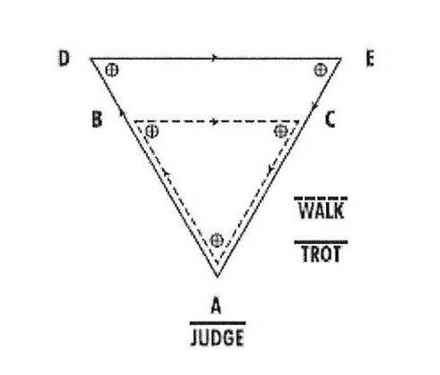

70 to 90 feet (21.34 to 27.43 m) between corner markers

Scoring System: 60% movement, 30% conformation, 10% temperament.

If a horse knocks over a cone or marker, they are to be scored accordingly. This does not constitute immediate disqualification but at the judge’s discretion can be penalized in the temperament or movement score.

If a horse or exhibitor falls, they are to be scored accordingly. This

does not constitute immediate disqualification but at the judge’s discretion can be penalized in the temperament or movement score. If a horse is off pattern either by completing the large triangle ADEA before the small triangle ABCA, by not displaying the correct gait while completing the corresponding triangle or by not submitting to inspection prior to completing the pattern, the entry shall be disqualified. An appropriate penalty shall be assessed at the judge’s discretion

for break of gait during completion of the pattern, but this shall

not constitute off pattern or immediate disqualification.

B. Showmanship:

Showing a horse is an art and should be considered as such by the showman and judge alike. Proper showing testifies to the obvious pride the showman has in his animal. Conformation of the horse is not judged. Judges are expected to be familiar with all breed standards and to judge on the ability of the showman. Technical points and minor infractions of the rules should not be over-emphasized to the extent that they outweigh the presentation of a clean, well-conditioned, trained animal.

The method of showing the horse is optional. Instructions will be given by the ring master or steward as designated by the judge. Styles of showmanship vary according to the breed.

1. Appearance of the Horse

a. Glossy-coated shine that is clean, healthy and muscled.

b. Excess fat or a thin, unthrifty condition is objectionable.

c. Areas around the eyes, ears, muzzle, nostrils, belly, between the legs and around the tail must be clean. Excess hair trimmed, ears need not be cleaned out.

d. Trimming of the mane and tail should be done according to breed standards.

e. The tack should be neat, clean, well fitted and should complement not detract from the horse.

f. Horses shown Western are to be shown in a halter. Leather and nylon are permissible.

g. Horses shown English may be shown either in a halter or bridle. Show halters must have a throat latch. Horses shown in a double rein bridle should have the snaffle rein lay over the withers and be handled with the curb rein. The snaffle rein, bit and cheek pieces may be removed from the full bridle and the horse shown with the chain under the horse’s jaw or over the horse’s nose shall be permitted.

2. The Exhibitor

Exhibitors must wear proper Western or English attire. (See Western or English Pleasure Class rules.)

3. Showing the Horse

a. The exhibitor should be ready to enter the ring in a brisk, alert manner. Exhibitors should watch for any instructions from the ringmaster/gate-person or judge. Showmanship is practiced from the time of entering the ring until after the class is completed.

b. Showman and horse should demonstrate the ability to work as a team. The horse responding to the slightest signals and being shown to the best advantage.

c. The horse must be under control at all times.

d. The exhibitor should not block the judge’s view of the horse.

4. The showman will lead from the left side with the lead shank about 8 - 12 inches from the halter. Light control should be used to allow the horse to hold its head naturally. A loose, floppy lead strap is held in the left hand in a figure 8 coil or loose loop. Kicking of the legs or pushing with the hands is objectionable.

5. The horse should move freely at a walk or trot (second gait for Tennessee Walkers.) Those breeds which do not trot should be shown by breed standards. The exhibitor should stay in position, by the near side of the horse’s neck, preferably between the horse’s head and shoulder.

6. The pattern for showing the horse will be designed by the judge. When moving toward or away from the judge or ringmaster/gate-person the horse should be a length away. Turns are usually made to the right. Turns less than 180 degrees may

be made to the left when common sense applies, but collection and control is a must. The exhibitor may find it necessary to make a Y turn to set the horse’s feet properly.

7. The horse should set up quickly, stand squarely and/or balanced and move forward or backward freely. The showman should remain in the safe zone on the near side and face slightly if the judge is working the front of the class. The showman should turn and face the rear (the lead may be switched to the left hand) or the horseman can step to the off side of the horse in the safety zone if the judge is working the rear of the class. A showman should not remain in the danger zone. The showman must pass around the horse as the judge moves around the animal as he should not be blocking the judges’ view of the horse.

8. Note the shaded areas of the drawing. These are the safe zones used by horseman when handling horses. It is permissible in halter and showmanship classes for the showman to move to either side of the horse. Note the DANGER ZONE in front of the horse. Remaining in this zone is considered a fault.

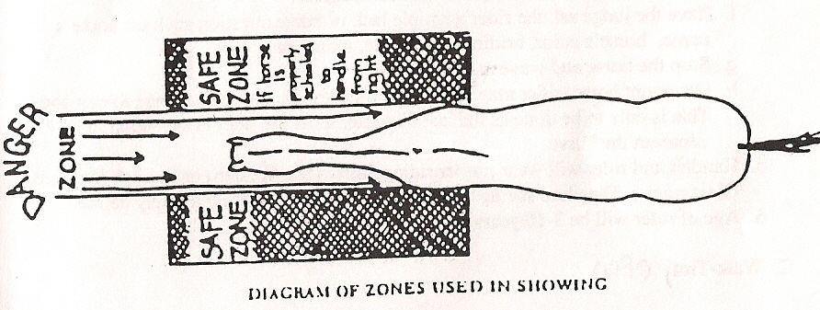

**Class 13. Miniature Horse Hunter in Hand**

1. General:

a. Horses must be three years old or older and 38” and under.

b. To be judged on style, manners, and way of going.

b. Preference given to those horses that cover the course at an even pace, with free flowing strides, such as a brisk trot or canter, must maintain same gait throughout the entire course.

d. Circling once upon entering the ring and once upon leaving the ring is permissible.

e. Athletic shoes are allowed

B. Course:

1. There will be a minimum of 4 fences and a maximum of 6 fences.

2. All jumps must have a ground pole.

3. Jump standards may not be taller than 40” and must be collapsible.

C. Faults

1. Causes for elimination in Hunter classes:

a. Three (3) refusals, b. Off Course, Fall of horse or exhibitor, c. Jumping of obstacle by exhibitor, d. carrying a whip, e. unsound horse.

2. Major faults to be scored:

a. Knockdowns b. Touches c. Refusals d. Bucking or Kicking e. Spooking or shying, F. Not maintaining an even pace.

**SECTION III. Performance Class Rules:**

A. Lead-Line

1. Class will be judged on the performance of the rider.

2. Handler and rider will wear proper riding attire. (See Western and English Pleasure Class rules.) Tapadero stirrups are allowed. Rider must wear safety helmets.

3. Age of rider will be 3 as of the day of the show - 10 years of age.

4. Rider may compete in Lead-Line Trail but may not compete in other performance classes.

5. This class will be judged at a walk only.

B. Lead-Line Trail

1. Judging will be based on the performance of the rider to negotiate the obstacles. Judging will be done by the judge of the day.

2. Classes will be held in an enclosed area inside or outside of the main ring and will be posted by 8:30 A.M.

3. Horses are not required to work the rail, but the course must be designed to require each horse to only walk (no lope or trot). Riders will be penalized for delays in doing an obstacle or if a refusal, will be asked to go on to the next, with no points given for that obstacle. Carelessness in negotiating obstacles will be similarly penalized. Failure to follow the course shall be penalized. In case of a tie, contestants will be required to work another obstacle. It is permissible to change hands to work an obstacle, hands to be around reins. Contestants will not be disqualified for touching the horn.

4. Five obstacles will be used and selected from the following approved list:

a. Walk over log or logs placed flat on the ground.

b. Stop horse at designated spot, and back horse up at least three (3) steps.

c. Zig-Zag through cones. (Cones to be set up at a distance that will be easily negotiated.)

d. Walk completely around an item such as a barrel or pole.

e. Turn horse either to the right or left 180 degrees.

f. Have the judge ask the rider a simple tack or horse question such as: horse’s name, horse’s color, bridle, rein, saddle, mane, ears, etc.

g. Stop the horse and wave at the audience.

h. Dismount horse (rider may have help, if necessary), and lead horse to exit gate. This is only to be done as the last obstacle, so as the rider is not required to remount the horse.

5. Handler and rider will wear proper riding attire. (See Western or English Pleasure Class rules.) Tapadero stirrups are allowed. Rider must wear a safety helmet.

6. Age of rider will be 3-10 years of age.

7. This class will be judged at a walk only.

8. The hosting club will provide the pattern.

C. Pleasure Driving, Open

1. Horse and/or pony will compete with the emphasis placed on the ability of the animal to give a pleasurable drive combined with safety and manners. Judging will be 80% on performance and ability of driver; 10% on conformation and 10% on appointments.

1. Miniature Horses must be 3 years or older to drive.

2. Horse/pony shall enter the ring to the right at a park gait (normal trot.) Each horse shall exhibit the following gaits: Walk, park gait (normal trot), and road gait (faster extended trot). Each shall demonstrate such gaits in both directions of the ring at the direction of the ringmaster/gate-person. Change of direction shall be done by crossing the ring at a walk or park gait only. Each horse shall also be required to back and stand quietly. Headers will be permitted in the line up at closer than three (3) feet from the horse.

3. Horse/pony shall compete in a driving class safely harnessed to a cart/buggy. The exhibitor and/or groom (optional) are to be a competent person and shall be the only person(s) permitted in such cart/buggy during exhibition. The cart/buggy shall be a pleasure type, two (2) to four (4) wheel, single horse with seats for one or two persons. All carts must be basket type equipped. No stirrup type carts or sulkies will be allowed. Dash and basket cover is optional.

4. Equipment to be used shall include a whip suitable to the cart/buggy, a collar or breast collar harness and standard bridle. Check reins, blinders, breeching or thimbles, martingales and cavesons noseband may be used at the option of the exhibitor. Any normal driving bit is accepted including half-cheek snaffle, liverpool, elbow driving and bradoon overcheck bit. All mouth pieces must be a minimum of 5/16" in diameter, measured one inch from the cheek. If the horse’s mouth is found bloody, disqualification is at the discretion of the judge.

5. Exhibitors shall be neatly attired. (English, Western or Driving Attire). A coat of choice plus English, Western or Driving hat to go with your outfit, or a safety-type helmet is permitted. Exhibitors may wear rain wear or inclement weather apparel if weather conditions require it. If a female exhibitor is attired in a short dress, a lap robe is required.

D. Junior Horse English Pleasure

1. Rules will be the same as in English Pleasure with the exception that the horse be five (5) years of age or under.

2. Rider will wear proper riding attire. (See English Pleasure Class rules.)

E. Senior Horse English Pleasure

1. Rules will be the same as in English Pleasure with the exception that the horse be six (6) years of age or older.

2. Rider will wear proper riding attire. (See English Pleasure Class rules.)

3. Horses shown in Junior & Senior Horse classes may also be shown in the riders English Pleasure age group. Points accumulated in the Junior Horse Class will automatically be added to the Senior Horse class for the 100/200 point award.

F. English Pleasure

1. Judging will be based on 60% performance and manners, 30% on type and quality and 10% on appointment.

2. Hunt horses to be shown at a walk, trot and canter both ways of the ring. Saddle horses may be asked to slow gait or rack. Walking horses to pace or running walk in place of trot. The order to reverse may be executed either toward or away from the rail. The horse will stand quietly and back readily.

3. Equipment for Hunters will be hunt or forward seat saddles; breastplates and light hunt show bridles. Martingales, tie-downs, figure eight or dropped nose band or draw reins are prohibited. Saddle horses will have flat saddles and pelhams or full bridles. No martingales, etc. Walking horses will use standard walking horse bit and bridle. If boots are used, they must be leather or unlined rubber bell boots, hinge bell or heel boots with leather strap only. No martingales, etc.

4. Attire for Hunter classes will be: Appropriate English Attire shall be worn for all English classes along with hunt helmets fitted and hunt boots. Ties or chokers are optional. Spurs of the unrowelled type and crops or whips are optional for Hunt, Saddle or Walking Horse attire. Saddle & Walking horse attire will be saddle suits or Kentucky Jodhpurs with appropriate jacket; collared shirt; derby or soft hat and jodhpur boots. No contrasting colors other than vest.

5. In extreme temperatures, it will be the decision of the Chairperson and the Judge, as to whether or not hunt coats need to be worn. Any shirt sleeve length will be allowed.

G. English Equitation

1. Riders will be judged on seat, hands, performance of the horse, appointments of the horse and rider, and suitability of horse to rider. Individual workouts are required prior to rail work and will count as 60% of the score.

2. Judge has the option to require rail work: Hunt horses to be shown at a walk, trot and canter one way of the ring. Saddle horses may be asked to slow gait or rack. Walking horses to pace or running walk in place of the trot. The order to reverse may be executed either toward or away from the rail.

Individual tests may include:

a. Backing

b. Dismount and mount

c. Pick up reins

d. Figure eight at trot demonstrating change of diagonal

e. Ride without stirrups

f. Figure eight at canter demonstrating simple change of lead

3. Horses must have proper equipment. (See English Pleasure Class rules.)

4. Rider will wear proper riding attire. (See English Pleasure Class rules.)

H. Walk/Trot Novice rider

1. Class will be judged on performance of the rider.

2. Rider will wear proper riding attire. (See Western or English Pleasure Class rules.)

3. Starting in the 2004 show season, a rider must not have competed in any other performance class, except Halter, Showmanship, Lead-Line, or Lead-Line Trail, either at a U.P.H.A. sanctioned show or other competitions.

4. Rider may choose to remain in this class, but once advanced may not return to this class. Points awarded in this class are not transferable to any other class.

I. Walk Trot Novice Horse

1. Class will be judged on performance of the horse

2. Rider will wear proper riding attire (see western or english pleasure class rules)

3. Horse cannot compete in any other class except: Halter, Showmanship, lead line, lead line trail, driving, and open walk trot.

J. Walk/Trot Pleasure, Open

1. Class will be judged on performance of the horse.

2. Rider will wear proper riding attire. (See Western or English Pleasure Class rules.)

K. Junior Horse Western Pleasure

1. Rules will be the same as in Western Pleasure with the exception that the horse be five (5) years of age or under.

2. Two hands will be allowed on the reins.

3. Rider will wear proper riding attire. (See Western Pleasure Class rules.)

L. Senior Horse Western Pleasure

1. Rules will be the same as in Western Pleasure with the exception that the horse be six (6) years of age or older.

2. Only one hand will be allowed on the reins.

3. Rider will wear proper riding attire. (See Western Pleasure Class rules.)

4. Horses shown in Junior & Senior Horse classes may also be shown in the riders Western Pleasure age group. Points accumulated in the Junior Horse class will automatically be added to the Senior Horse class for the 100/200 point awards.

M. Western Pleasure

1. Judging will be based 75% on manners and way of going, 25% on seat and attire.

2. Pleasure horses will be judged at a walk, trot and lope on a reasonably loose rein (only one hand permitted). Also on correct leads, response to commands and control over excessive speed. The reverse will be away from the rail. Backing is required.

3. Only humane bits, curbs, spurs, etc. will be allowed. Curb straps must be loose enough to allow 2 fingers under. Curb chains must be a minimum of 1/2" flat chain. Horses six years and older must be bitted. A romal is permissible. No mechanical hackamores or training devices are permissible. Tie-downs are prohibited, but breast straps are allowed. Regular western saddle required. No Tapaderos.

4. Western attire will include: western hats and boots, regular long sleeved shirts or blouses, western pants. Belts are optional. Neckties, pin, bows, bolos, spurs and chaps are optional. NO western fashion boots.

N. Western Disciplined Rail

Disciplined Rail is an advanced class which tests the skills of both horse and rider, as they execute specific gaits, transitions and movements as requested by the judge. Following are some, but not all, of the items the judge may ask you to perform:

1. Transitions to and from any gait, such as trot to canter, hand gallop to halt, halt to canter, trot to counter canter, etc. You may also be asked to perform a gait for a specific number of steps or strides.

2. Counter canter.

3. Extension and collection of any gait.

4. Sidepass

5. Pivot or forehand turn for a specific number of degrees.

6. Back

7. Change leads (Example: “As you pass in front of the judge, perform a simple change of lead.”)

8. Depending upon the number of participants in the arena, you may be asked to reverse at a trot

9. Walk “on the buckle”.

10. Leg-yield away from and back to the rail.

O. Western Horsemanship

1. Riders will be judged on seat, hands, performance of the horse, appointments of the horse and rider and suitability of horse to rider. Individual workouts are required prior to rail work and will count as 60% of the score. Only one hand will be allowed on the reins.

2. Judge has the option to require rail work: Horses to be shown at a walk, trot, and lope one way of the ring. The reverse will be away from the rail.

Individual tests may include:

a. Backing

b. Figure eight at a jog

c. Lope and stop

d. Figure eight at the lope demonstrating simple changes of lead. One figure eight will demonstrate two changes of leads if it is completed by closing up the last circle and stopping in the center of the eight.

e. Ride without stirrups

f. Change lead down center of the ring demonstrating simple

lead change.

3. Horses must have proper equipment. (See Western Pleasure Class rules.)

4. Rider will wear proper riding attire. (See Western Pleasure Class rules.)

P. Western Riding

1. Rider is judged on the ability to govern, control and properly exhibit the horse in the required pattern. Emphasis shall be placed on the position in the saddle, lightness of hand, change of leads and smoothness of gaits. Riders 13 and under may drop to a trot and use simple lead changes. Preference shall be given to flying lead changes throughout the entire class.

2. The riders’ free hand must be kept off the horse and equipment. The rider is penalized if he uses two hands on the reins, changes hands on the reins or touches any part of the saddle or horse with his free hand. The rider is penalized if he/she loses a stirrup. Not following the exact pattern is a disqualification. Knocking down of markers or obstacles will not disqualify but shall be scored down. It is a fall when the horses shoulder touches the ground or when a rider comes in contact with the ground and a fall is a disqualification. Spurs or romal shall not be used forward of the cinch. Romal reins must be held correctly.

3. Horses six years or older must have a bit, five years and under may use a bosal. If a romal is used, hobbles must be carried. Spurs, breast collar, skid boots or chaps are optional. No ropes, hackamore bits, running martingales, tie-downs, draw reins, whips, bats, nosebands or wire curbs are allowed. Chain curbs are permissible if at least 1/2" in width and lying flat. Lack of required appointments will be cause for disqualification. The judge may inspect equipment at the initial lineup. The rider will be allowed to change providing he is able to compete before the last horse has completed the class.

4. Riders must wear proper riding attire. (See Western Pleasure Class rules.)

5. The pattern is as follows: Markers or kegs should be a distance of 30 feet and any color. The obstacle, one small log, is just high enough to break the animals stride in going over. The dotted line is the walk. The dashed line the trot, the solid line the lope and the curvy line the back. Upon completion the rider will ride to the judge for equipment inspection. The rider may be required to repeat any part of the routine. This is not a timed event. The use of a gate is optional.

WESTERN RIDING PATTERN #1

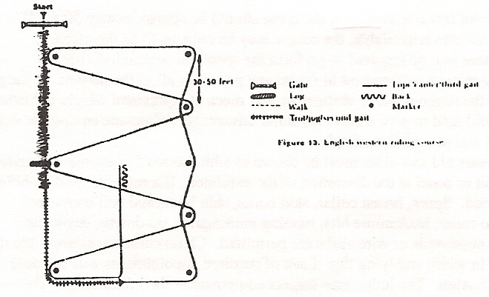

WESTERN RIDING PATTERN # 2

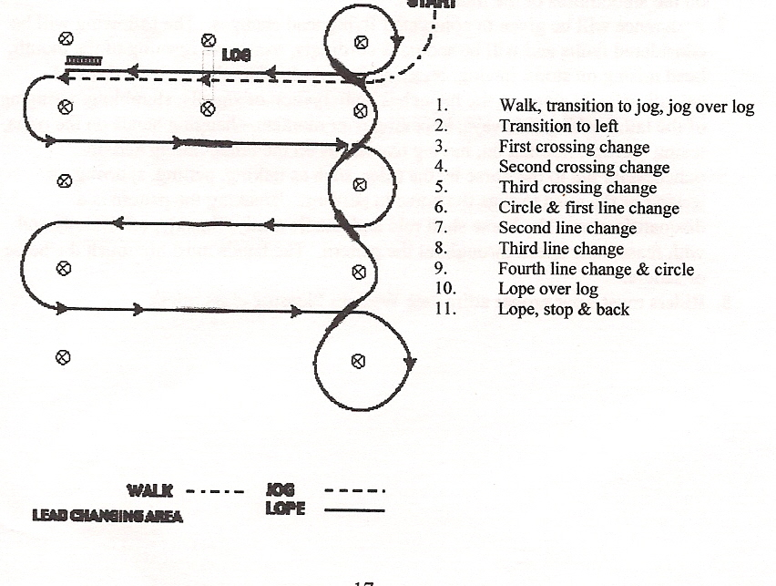

WESTERN RIDING PATTERN #3

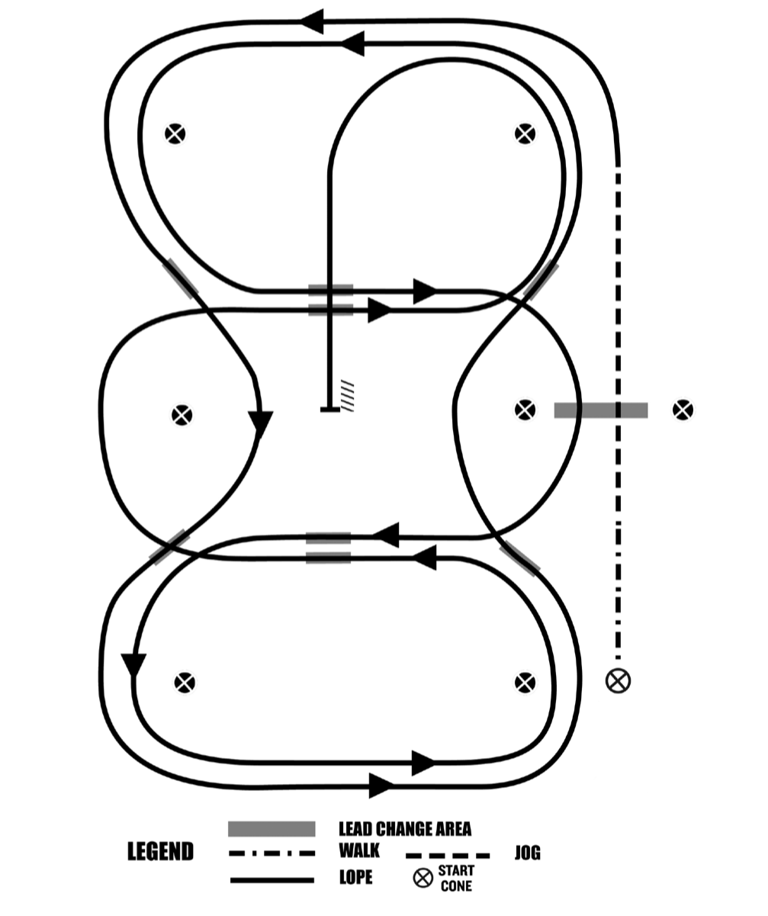

1. Walk, transition to jog, jog over log
2. Transition to the lope, on the left lead
3. First line change
4. Second line change
5. Third line change
6. Fourth line change
7. First crossing change
8. Lope over log
9. Second crossing change
10. Third crossing change
11. Fourth crossing change12. Lope, stop & back

Q. Reining

1. Where sufficient space is available, the arena should be approximately 50' x 150'. If only a smaller area is available, the course may be reduced to fit the arena.

2. Each contestant will be required to perform the specified pattern individually.

3. A judge may request a contestant to repeat any part of or the entire pattern. A judge may require the removal of, or changes in, any piece of equipment which, in his/her opinion, would tend to give a horse an unfair advantage. Inhumane equipment will be penalized and scored accordingly.

4. Horses six years old and older must be shown in a bit, horses 5 years old and under may use a bit or bosal at the discretion of the exhibitor. If a romal is used, hobbles must be carried. Spurs, breast collar, skid boots, shin boots and bell boots are optional. No ropes, hackamore bits, running martingales, tie-downs, draw reins, whips, bats, nosebands or wire curbs are permitted. Chain curbs are permissible if at least 1/2" in width and lying flat. Lack of required appointments will be cause for disqualification. The judge may inspect equipment at the initial setup. The rider will be allowed to change, providing he/she is able to compete before the last horse has completed the class.

5. Spurs or romal shall not be used forward of the cinch. Romal reins must be held correctly.

6. The horse will be judged on the neatness, ease, calmness, speed and dispatch with which it performs the pattern. Use of the third gait by gaited horses will be judged on the smoothness of the transitions.

7. Preference will be given to complete flying lead changes. The following will be considered faults and will be scored accordingly; excessive opening of the mouth, head raising on stops, jawing, breaking gaits, refusal to change leads, lack of smooth straight stops on the haunches, anticipation of signals, stumbling, wringing of the tail, backing sideways, knocking over markers, changing hands on the reins, losing stirrups, holding on, having two hands on the reins, falling and/or unnecessary aid to the horse by the rider, such as talking, petting, spurring, or jerking of the reins to urge the horse to perform. Breaking the pattern is a disqualification. The horse shall rein and handle easily, fluently, effortlessly and with reasonable speed throughout the pattern. The hands must not touch the horse or saddle.

8. Riders must wear proper riding attire. (See Western Pleasure Class rules.)

The judge will indicate the length of the pattern with markers on the arena fence or wall, markers within the area of the pattern will not be used. The ride patterns are as follows:

PATTERN - NRHA Pattern 3

1***.***  Run around end of arena, run down side past center marker, left rollback.

2. Run around end of arena, run down side past center marker, right rollback.

3. Right circles – 2 large fast, 1 small slow, change leads.

4. Left circles – 2 large fast, 1 small slow, change leads.

5. Run ¾ of circle, run completely around the arena, past center marker, stop, back-up, hesitate.

6. Four right spins, hesitate.

7. Four left spins, hesitate.

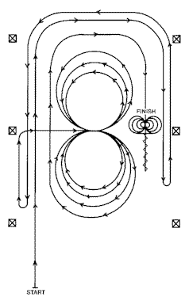

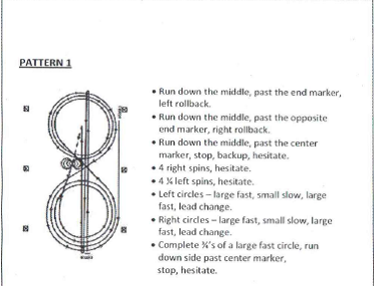

ORHA GREEN AS GRASS PATTERN ‘A’

. Rider may NOT change hands during the pattern. Rider MUST finish the pattern as he/she started it. LEAD CHANGES are to be true flying changes - NO simple changes.

Penalties for missed changes will be deducted as per NRHA rule book.

Beginning at the center of the arena facing the left wall:

1. Beginning on the LEFT lead, complete two circles to the left; the first circle large and fast, the second circle small and slow. Stop at the center of the arena.

2. Complete 2 spins to the LEFT. Hesitate.

3. Beginning on the RIGHT lead, complete two circles to the right; the first circle large and fast, the second circle small and slow. Stop at the center of the arena.

4. Complete 2 spins to the RIGHT. Hesitate.

5. Beginning on the LEFT lead, run a large fast circle to the left CHANGING LEADS at the center of the arena, run a large fast circle to the right and CHANGE LEADS at the center of the arena.

6. Continue around the previous circle to the left, but do not close this circle. Continue up the right side of the arena staying at least twenty feet from the wall or fence, past the center marker do a SLIDING STOP and do a RIGHT ROLLBACK. No hesitation.

7. Continue around bottom end of the arena, run straight down the left side of the arena staying at least twenty feet from the wall or fence, past the center marker do a SLIDING STOP and do a LEFT ROLLBACK. No hesitation.

8. Continue around the bottom end of the arena, staying at least twenty feet from the wall or fence, run straight down the right side of the arena, past the center marker, do a SLIDING STOP. BACK UP at least ten feet. HESITATE to demonstrate completion of the pattern.

Rider must dismount and drop bridle to the designated judge.



ORHA GREEN AS GRASS PATTERN ‘B’

Rider MAY ride with one or two hands. Rider may NOT change hands during the pattern. Rider MUST finish the pattern as he/she started it. LEAD CHANGES are to be true flying changes-NO simple changes.

Penalties for missed changes will be deducted as per NRHA rule book.

Beginning at the center of the arena facing the left wall:

1. Complete 2 spins to the RIGHT. Hesitate.

2. Complete 2 spins to the LEFT. Hesitate.

3. Beginning on the LEFT lead, complete 3 circles to the left, the first large and fast, the second small and slow, the third large and fast. CHANGE LEADS at the center of the arena.

4. Complete 3 circles to the RIGHT; the first large and fast, the second small and slow, the third large and fast. CHANGE LEADS at the center of the arena.

5. Begin a large fast circle to the LEFT but do not close the circle. Run up the right side of the arena past the center marker and do a SLIDING STOP and a RIGHT ROLL BACK at least twenty feet from the wall or fence. No hesitation.

6. Continue back around previous circle but do not close the circle. Run up left side of the arena past the center marker and do a SLIDING STOP and a LEFT ROLL BACK at least twenty feet from the wall or fence. No hesitation.

7. Continue back around previous circle but do not close this circle. Run up right side of the arena past center marker and do a SLIDING STOP at least twenty feet from the wall or fence. BACK UP at least ten feet. HESITATE to demonstrate completion of the pattern.

Rider must dismount and drop the bridle to the designated judge.



R. Ranch Riding

1. The horse should reflect the versatility, attitude, and movement of a working horse.

2. The horse’s performance should simulate a horse riding outside the confines of an arena and that of a working ranch horse. This class should show the horse’s ability to work at a forward, working speed while under control of the rider. Light contact should be rewarded, the horse does not have to be shown on a full drape of reins. The overall manners and responsiveness of the horse while performing the maneuver requirements, and the horse’s quality of movement are the primary considerations.

3. No horses less than 3 years of age.

4. Each horse will work individually, performing both required and optional maneuvers, and scored on the basis of 0 to 100, with 70 denoting an average performance.

5. The required maneuvers will include the walk, jog, and lope both directions, and the extended jog and lope at least one direction, as well as stops, turn to change directions, and back.

6. Three optional maneuvers may include a side pass, turns of 360 or more, change of lead (simple or flying), walk, jog, or lope over a pole(s), or a simple combination of maneuvers that would be reasonable for a ranch horse to perform.

7. The maneuvers may be arranged in various combinations with final approval by the judge.

8. The overall cadence and performance of the gaits should be with an emphasis on forward movement, free-flowing, and ground covering for all gaits. Transitions should be performed where designated, with smoothness and responsiveness.

9. No time limit.

10. One of the suggested 4 patterns may be used, however a judge may utilize a different pattern as long as all required maneuvers are included plus 3 or more optional maneuvers are included. Patterns as per A.Q.H.A. rule book.

11. Failure to perform a required maneuver will result in a horse placing below all other horses that perform all maneuvers.

12. No hoof polish. No braided or banded manes or tail extensions. Trimming inside ears is discouraged. Trimming the bridle path, trimming of fetlocks or excessive facial hair is allowed.

13. Equipment with silver should not count over a good working outfit. Silver on bridles and saddles is discouraged.

RANCH HORSE PATTERN #1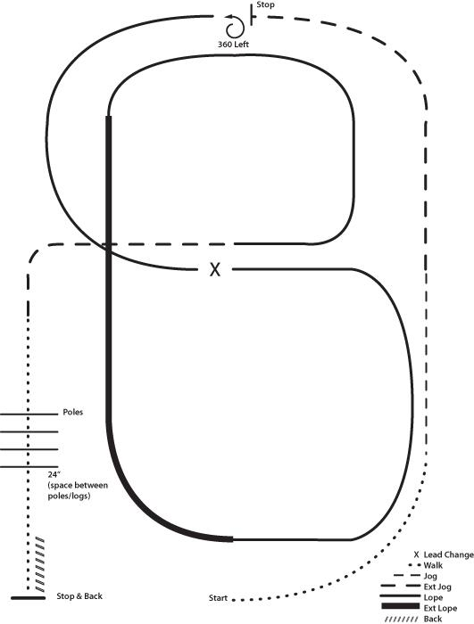

RANCH PLEASURE – PATTERN I

1. Walk

2. Jog

3. Extend the jog, at the top of the arena, stop

4. 360 turn to the left

5. Left lead 1/2 circle, lope to the center

6. Change leads (simple or flying)

7. Right lead 1/2 circle

8. Extended lope up the long side of the arena (right lead)

9. Collect back to a lope around the top of the arena and back to center

10. Break down to a jog

11. Walk over poles

12. Stop and back

RANCH PLEASURE – PATTERN II

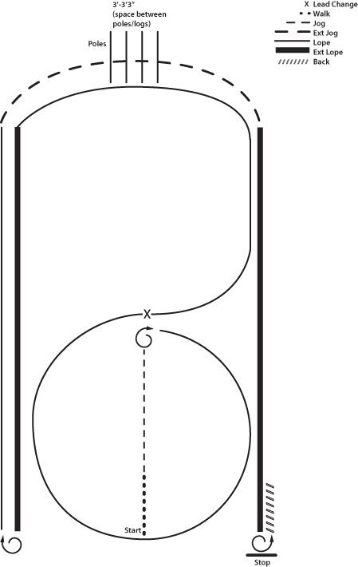

1. Walk

2. Jog

3. Stop, do 1 1/4 turn to the right

4. Lope small circle on the right lead

5. Change leads, (simple or flying) lope left lead around end of the arena

6. Extend the lope on the left lead

7. Stop, do 2 1/2 turns right

8. Lope straight on the right lead

9. Extend the jog around end of the arena across poles/logs

10. Extend lope on right lead

11. Stop, do 2 turns left

12. Back

RANCH PLEASURE – PATTERN III

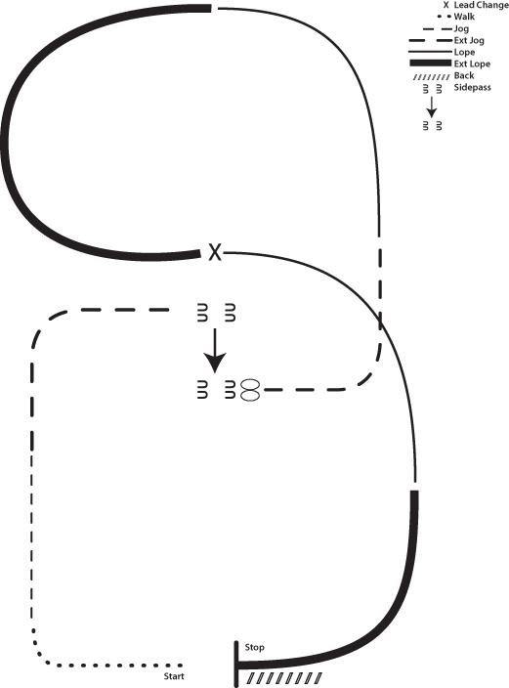

1. Walk to the left around corner of the arena

2. Jog

3. Extend alongside of the arena and around the corner to center

4. Stop, side pass right

5. 360 turn each direction (either way 1st)

6. Extend the jog

7. Lope left lead

8. Extend the lope

9. Change leads (simple or flying)

10. Collect to the lope

11. Extend the lope

12. Stop and back

RANCH PLEASURE – PATTERN IV

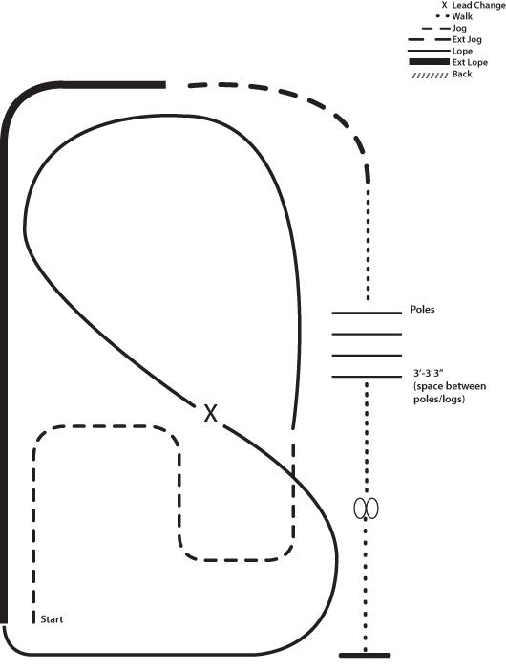

1. Jog serpentine

2. Lope left lead around the end of the arena and then diagonally across the arena

3. Change leads (simple or flying) and lope on the right lead around end of the arena

4. Extend lope on the straight away and around corner to the center of the arena

5. Extend jog around corner of the arena

6. Collect to a jog, jog over poles

7. Stop, do 360 turn each direction (either direction 1st) (L-R or R-L)

8. Walk

S. Trail

1. Miniature Horse Trail Class

a. Exhibitor must wear proper Western or English attire. Hat is optional.

b. Class will be judged 100 % on manner of horse’s performance through the course. Judging to be done by the judge of the day.

c. Class will be held in an enclosed area, either in or outside of the main ring. Class pattern will be posted by 8:30 A.M. EST.

d. There is a sixty second time limit to complete each obstacle. After time is used, the exhibitor will be directed to the next obstacle. Refusals to do an obstacle do not constitute class disqualification.

e. Edible treats to encourage an animal to perform one of the obstacles are not allowed.

f. Obstacles should be safe for exhibitors as well as for horses.

g. Off course will result in elimination from the class. Off course is defined as: taking an obstacle in the wrong direction, negotiating an obstacle from the wrong side, skipping an obstacle unless directed by the judge and negotiating obstacles in the wrong sequence.

h. Obstacles will be used and selected from the following approved list:

1. Bridge

2. Tarp

3. Carry object over the back of horse from one place to another.

4. Side pass over pole placed flat on the ground.

5. Back through an “L” with a 28” minimum spacing.

6. Serpentine through cones.

2. Trail Class - 18 and Under / 19 and Over/ Trail in hand Open (walk and trot only)

a. Judging will be based on the performance of the horse negotiating the obstacles with emphasis on manners, attitude and response to the rider. Judging is to be done by the judge of the day.

b. Class will be held in an enclosed area either outside of the main ring or in the main ring and be posted by 8:30 A.M. EST.

c. Horses are not required to work the rail, but the course must be designed to require each horse to walk, trot and lope (walk and trot only for in hand trail) somewhere on the course. Horses will be penalized for delays in doing an obstacle or if a refusal, will be asked to go on to the next with no points given for that obstacle. Excessive speed or carelessness in negotiating obstacles will be similarly penalized.

d. In hand trail maybe shown with a saddle but must be shown in a halter. All ages are able to be shown.

e. If showing in the in hand trail you are not allowed to cross enter into the riding trail with the same horse/ rider combination.

Failure to follow the course shall be disqualification. In the case of a tie, contestants will be required to work another obstacle. It is permissible to change hands to work an obstacle before it is started; hands to be around the reins, index finger only between reins, except when using a romal. Riders hands to be clear of horse and saddle. No spurs or romal shall be used forward of the cinch.

d. A minimum of six obstacles will be used, maximum of ten, a minimum of three obstacles selected from the following list and the remaining three to six at the discretion of the sponsoring club, keeping in mind safety and age appropriateness. All clubs are encouraged to use wooden poles instead of PVC pipes. U.P.H.A. approved list:

1. Opening, passing thru and closing gate.

2. Ride over at least four poles, either in a straight line, zig- zagged or raised. Raised or normal walk-overs are to be 24 inches apart. Trot poles will be 3 feet apart and 6 feet for loping.

3. Back through an “L” with 28 inches minimum spacing, or back through and around three markers (no barrels) set in a line or triangle. If using the “L” must first walk through and then proceed to back through.

4. Carry an object from one area of the arena another.

5. Put on and remove a slicker.

6. Remove and replace items from a mailbox.

7. Side pass over an obstacle.

8. Ground tie.

9. Ride/lead over a wooden bridge at least 3 feet wide by 6 feet long.

10. Execute a 360 degree turn on the forehand or haunches with all four feet within a box. The turn specified the day of the show. The square box of rails is to be 5 to 7 feet square.

e. Horses must have proper equipment but hobbles and leg protection are optional. (See Western or English Pleasure Class rules.)

f. Riders must wear proper riding attire. (See Western or English Pleasure Class rules.)

**Section IV. TIMED EVENT (SPEED CLASSES) GENERAL RULES:**

A. Speed events will not start until after 2:00 p.m., however speed classes may be held on Friday or Saturday nights starting at 6:00 p.m. if requested by a club.

B. No horses may run more than once in an event except when involved in a tie, breakage of equipment, or the timer malfunctions.

C. Courses must be laid out to allow sufficient room for stopping and turning as indicated in diagram. There must be an enclosed safety holding area for all speed events of sufficient strength to deter contestants from leaving the area. It must be of snow fence or better. No rope or wire.

D. A running start will be allowed if there is an adequate holding area. Only participating contestants will be allowed in the pen during the class.

E. An electric timer must be used. A backup stop watch will also be used. In case of timer failure the contestant may either take the stop watch time or run the pattern again using the electric timer.

F. Western type equipment is required. Bosal, hackamore and any humane bit is allowed. The judge or ringmaster may disqualify any contestant if equipment is considered unsafe or inhumane.

G. Neat western attire required: shirt-no short sleeves, belt and boots. Western hats and/or safety riding helmets are optional for contestants 19 and over. (Remember, safety helmets are required for all contestants 18 and under.) No other caps or head covering is allowed.

H. Two hands may be used anytime the horse is in motion for reestablishing balance and as an aid for stopping. This rule applies to speed events only. Excessive spurring, whipping, etc.will not be permitted. No hitting allowed in front of the cinch.

I. Only horse show officials should be allowed in the timing booth during running of timed events.

**SECTION V. SPEED EVENTS:**

A. Barrel Racing

1. Barrels will be spaced in a triangular pattern. The first being 40 feet from the starting line, 70 feet to the second barrel, 90 feet to the furthest barrel and return to the start. If a reduction of course is required, the reduction is to be an equal increment (consult the diagram).

2. If the barrels are metal, they must be protected with rubber rings or tires at the top. Plastic barrels may be used if within specifications.

3. It is permissible to start with either the right or left barrel. When starting with the right barrel the pattern shall be as follows: right barrel clockwise; left barrel counter-clockwise; further barrel counter-clockwise.

4. The contestant will loose 5 seconds per barrel if knocked down. They will be disqualified for not following the pattern or for touching a barrel with hand.

*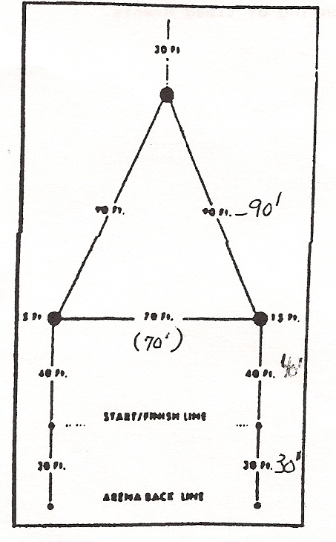Barrel Racing*

B. Midwest Flags

1. Three barrels should be placed at a 15' distance from all fences or walls. The distance from barrels 1 to 2 to 3 is 100'. The distance across the base of the triangle from barrel 1 to barrel 3 should be 70 feet. The bucket should be filled with sand and should be placed on the barrels as a depository for the flag. The length of the flag sticks should be 12" to 16" above the edge of the bucket. Wooden doweling 3/4" in diameter or other round suitable material should be used for the flag. The bucket should be 8" high. Two kegs, pylons, or like obstacles should be set on the starting line. Barrels 1 and 3 are to be 40 feet from the start/finish line. The horse and rider must start within 25' of the markers on the starting line (consult the diagram).

2. Contestants have the option of riding course A or B as follows:

a. The entry shall cross the starting line and begin following the pattern to the left, OR;

b. The entry shall cross the starting line and begin following the pattern to the right

c. The contestant will pick up a flag at 1, ride behind 2 and place the flag in the bucket at barrel 3. The flag must be placed into the bucket with the flag up-right.

3. Cause for disqualification will be as follows:

a. Hitting of any part of the horse/pony’s body with the flag or stick.

b. Dropping the flag.

c. Knocking over any of the barrels or knocking the bucket off, or over on the barrel.

d. Not following the pattern.

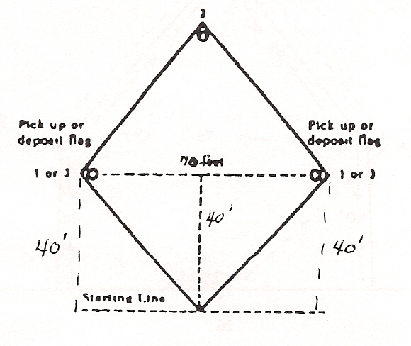

*Midwest flags*

C. Home Run

1. Home Run is run as if the horse and rider were running the base pattern of a baseball diamond. The base would be two poles set seven feet apart so that the horse and rider run between the two poles. The horse and rider may either start on the left set of bases or the right set of bases, running through all three sets of bases and back to the starting line.

2. Home run will be set up as the same size as the barrel pattern. After Midwest flags are finished leave the barrels in place, put a pole on either side of the barrel a distance of five feet apart, so there is enough room for a horse and rider to race through. Once the poles are in place, remove the three barrels.

3. Poles will be spaced in a triangular pattern. The first base (2 poles being 5’ apart) being 40’ from the starting line. 70' to the third base (2 poles being 5’ apart), 90’ to second base (2 poles 5’ apart). If a reduction of course is required, the reduction is to be in equal increments.

4. The horse and rider must start at the starting line and run to either first or third base (through the two poles) and continue on to second base, and then through the last base and then home. Failure to pass between the two poles representing the bases will be cause for disqualification. There is a three second penalty for each pole knocked over.

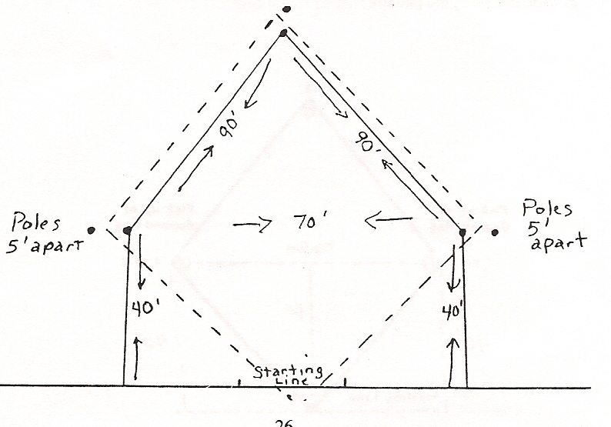

*Home Run*

D. Plug Race

1. One barrel is to be placed 150’ from the center of the gate.

2. The contestant is to ride down around the barrel either to the right or left and ride back out of the gate.

3. There will be a 5 second penalty for knocking over the barrel or touching it with the hand. The Contestant will be disqualified for not following the pattern.

E. Scuda Hole

1. Five (5) poles will be placed in a straight line 21’ apart to the right of the starting gate. The rider shall weave thru the poles starting to the right of the first pole. A low jump shall be placed 63’ from the starting gate, horizontal with the gate and even with the third pole. The contestant shall come from the last pole and go over the jump. Three (3) barrels are to be placed in a straight line to the left of the gate. The first to be placed directly across from the first pole; the second across from the third pole; and the third across from the fifth pole. The contestant shall turn from the jump, weave thru the barrels starting on the left of the first barrel, turn the last barrel and finish by running straight to the gate between the jump and barrels.

2. The contestant will receive a three second penalty for each pole knocked over, and knocking over or refusing the jump; a five second penalty for knocking over a barrel and disqualification for touching a pole or barrel, or for not following the pattern.

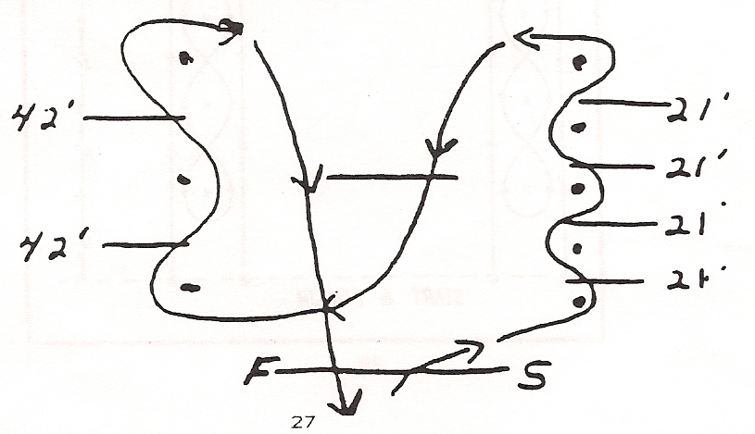

***Scuda-Hole***

F. Pole Bending

1. The pattern is to be run around six (6) poles. Each pole is to be 21’ apart and the first pole is to be 21’ from the starting line. They will have a 14’ base, 3/8” thickness, be of lightweight conduit pipe 6’ tall.

2. A contestant may start either to the right or left of the first pole and then run the remainder of the pattern accordingly.

3. The contestant will lose 3 seconds per pole if knocked down. They will be disqualified for touching a pole or not following the pattern.

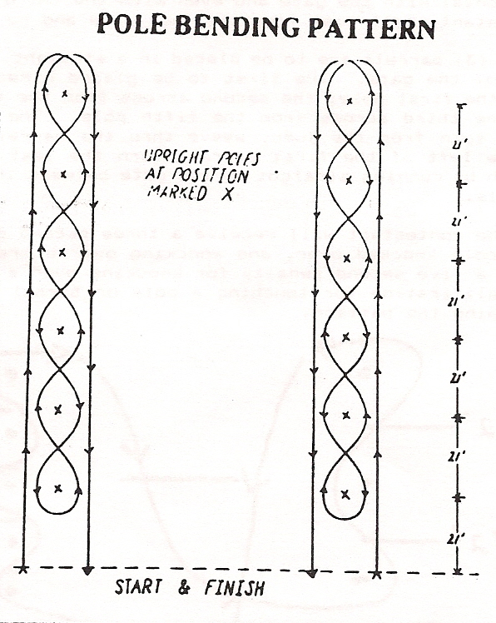

G. STAKES RACE

1. The contestant is allowed a running start and may begin his run from either the left or right side of the first pole. Start by crossing the center line between the upright markers, turn around the second pole, cross over the center line again between the markers, then around the first pole and run back across the finish line.

2. The start and finish line is 20 feet (6 meters) wide and marked by two upright markers 10 feet (3 meters) on each side of the center line and short enough so as to not interfere with the timer if one is used. Short pylons or cones are recommended. The first and second poles marking the center line are each 40 feet (12 meters) from the start and finish line, making them a total of 80 feet (24 meters) apart.

4. If an upright marker or pole is knocked down it shall result in 5 second penalty.

5. If pattern is broken, disqualification will occur.

